Victoria College and Victoria Independent School District Dual Enrollment Partnership Agreement
Academic Years: 2024-2025, 2025-2026, and 2026-2027

Introduction:
Victoria College (VC) and Victoria Independent School District (VISD) agree to enter into a partnership to offer dual credit courses to eligible students, allowing them to earn college credits while simultaneously fulfilling high school graduation requirements. This Memorandum of Understanding (MOU) will be in effect for the entitled academic year unless both parties agree to amend the agreement. The specific responsibilities of VC and the partnering high school are outlined within this agreement.

This MOU incorporates by reference all dual enrollment requirements defined in the Texas Administrative Code (TAC) and VC accreditation requirements established by the Southern Association of Colleges and Schools Commission on Colleges (SACSCOC). VC is committed to student success and will collaborate with high school personnel to select courses that ensure the completion of degrees and/or certificates and transferability to Texas public four-year Institutions.

Program Goals:
In accordance with HB 1638, TEC, Section 28.009 (b-1) and (b-2), which requires Texas Higher Education Board (THECB) and the Texas Education Agency (TEA) to develop statewide goals collaboratively, VC and VISD establish the following mutual goals in support of the dual credit program.

- Goal 1: Implement purposeful and collaborative outreach efforts to inform all students and parents of the benefits and costs of dual credit, including enrollment and fee policies.
- Goal 2: Assist high school students in the successful transition to and acceleration through post­ secondary education.
- Goal 3: Provide academic and college readiness advising with access to student support services to bridge dual credit students successfully into college courses and program completion.
- Goal 4: Ensure that the quality and rigor of dual credit courses is sufficient to ensure student success in subsequent courses.

Definitions:
When used in this MOU, the following words and terms shall have the following meaning unless the context clearly indicates otherwise.

- Dual enrollment refers to a system under which a student enrolled in multiple educational institutions (including a high school and a public institution of higher education). When a dual enrollment system student enrolls in courses, that student earns appropriate course credit from each distinct educational institution that offers the course. Dual enrollment is not equivalent to dual credit.

- Dual credit is a system under which an eligible high school student enrolls in college course(s) and receives credit for the courses(s) from both the college and the high school. Neither the location nor course modality determines dual credit qualification.
- Early admissions is a system under which an eligible high school student enrolls in college course(s) and receives only credit for the courses{s) from the college.

Student Eligibility:
To enroll in dual credit courses, high school students must:
- Attend a Dual Credit Information (DCI) session with a parent, guardian, or responsible adult
- Meet relevant VC course prerequisites required for the intended course(s).
- Be enrolled in grades 9-12
  - This includes the summer before the 9th grade, with confirmation of successful completion of 8th grade.
- Meet all dual enrollment (DE) admission requirements for VC, as outlined in the Guide to Dual Enrollment & Early Admission and the current college catalog, along with any additional school district requirements listed below.
- Texas Success Initiative Assessment (TSIA) or TSIA 2.0 minimum passing scores, or other college
readiness criteria listed in Appendix A
  - If the high school is a TSIA 2.0 testing site, students must submit a TSI Retrieval Form to VC's Department of Enrollment Services, or official score reports may be sent by high school officials
  - Students with fewer than 15 earned credit hours will be classified as non-degree seeking. However, once a student earns 15 credit hours, required college-readiness scores on the TSIA2 apply (Appendix A). It is recommended that students take college readiness courses within their first 14 credit hours. Students may become TSI ELAR complete by successfully completing with a C or better one of the following courses: ENGL 1301, ENGL 2311, or HUMA 1301. Students become TSI Math complete by successfully completing with a C or better one of the following courses: MATH 1332 (non-algebra complete), MATH 1342 {non-algebra complete), MATH 1314, MATH 1316, or MATH 1324.

Course Eligibility and Alignment:
College-level academic courses will comply with the THECB and SACSCOC regulations. Eligible courses must be recognized as college-level academic courses adhering to descriptions and content defined in the current editions of the Academic Course Guide Manual {ACGM) or technical courses listed within the Workforce Education Course Manual (WECM), either leading to marketable skills, awards, certificates, or degrees. The faculty and administration of VC and VIS0 have reviewed the curriculum requirements and standards for each college course listed in Appendix C and determined that successful completion of the identified college curriculum will provide mastery of the knowledge and skills set out by the TEA for the related high school course(s). This review Included the knowledge and skills required by the TEA for high school courses, descriptions from the ACGM, the WECM, and the departmental course syllabi for the college courses.

Eligible courses must provide advanced academic instruction that goes beyond and enables students to master the Texas Essential Knowledge and Skills (TEKS) more than the equivalent high school course. Remedial and developmental education courses are not approved for dual credit. For a full list of all dual credit courses offered by VC with dual credit pricing and a guarantee of open educational resources, see Appendix C. Dual enrollment tuition will not exceed rates set by the VC Board of Trustees and THECB. Each high school retains final authority on the courses offered to their students. Any course not listed on Appendix C may have book
costs and is subject to traditional tuition and fee schedules. VISD will award dual credit for all courses listed on
AppendixC.

Course Schedules & Planning:
VC College Access staff and high school counselors will communicate and coordinate dual enrollment course needs and interests during the prior semester. The high school counselor will provide the courses, times, and days requested using the Course Request link provided by Victoria College. Victoria College's academic calendar will be available on the VC website for review.

Course Location, Size, & Student Composition of Classes:
Courses may be conducted at the main campus, high school(s), a VC center, or online. Victoria College will provide the necessary facilities, such as a classroom with desks and telecommunications equipment, when held at the college campus or center. Conversely, when courses are offered at the high school, the high school will supply the required facilities and equipment. VC is not responsible for student transportation to or from the college campus or other off-site locations for dual credit courses. For online courses, the college will adhere to the THECB's Principles of Good Practice for electronically offered courses.

Regarding facilities and communication lines, unless otherwise arranged, the following agreements apply:
- For telecommunications courses originating from the college campus and delivered to a high school, the college is responsible for providing the facilities and equipment necessary for delivery, while the school district must ensure adequate facilities, equipment, and communication lines to receive the course.
- For telecommunications courses originating from the college campus and delivered to a college center, the college will handle equipment for both delivery and reception, while the center is responsible for providing suitable facilities and communication lines to receive the course.
- Each site must have a proctor a responsible adult who facilitates real-time remote courses. The proctor, who must not be a dual credit student or enrolled in the course to be proctored, must supervise the class, distribute materials, proctor exams, manage the classroom, and address any technical issues with the remote equipment. The proctor is also responsible for obtaining and verifying the class roster and communicating any changes to the college faculty. A handbook will be provided, and a signed agreement must be returned to the Dean of College Access and Community Partnerships. Proctors will be evaluated at the end of each semester.
- For science courses, the high school must ensure access to instructional resources and technology, meet laboratory safety standards, and comply with college science program requirements.
- Dual credit courses may consist solely of dual credit students or a mix of dual credit and college credit students. The inclusion of non-dual credit high school students in a dual credit course at a high school must be communicated to the Executive Vice President- Chief Academic Officer and noted as an exception as described in TAC 4.85 (d). Live courses taught at locations other than the college campus may include only dual credit students or a mix of dual and college credit students under the following condition.
- If the course involved is required for completion under the State Board of Education Recommended or Distinguished Achievement High School Program graduation requirements, and the high school involved is otherwise unable to offer such a course.
- The college sets the maximum class size and reserves the right to accept or reject new students during the add/drop period. The high school must ensure that the classroom environment supports college­ level learning.

Course Curriculum, Materials, Instruction, Grading & Transcription of Credit:
Dual enrollment courses will replicate the college courses offered to college credit students, including curriculum, materials, instruction, grading, and rigor. VC will ensure that grading for these courses adheres to the same standards and scale as for all other students. Students enrolled in college courses are considered college students. VC will report grades electronically to the high school counselor(s). Beginning Fall 2025, numerical grades or cumulative points will be reported during weeks four and twelve. Mid-term and final grades will be provided to the high school counselor electronically in numerical form. VC will not Issue "fail" notices to districts for UIL purposes. Each student's college transcript will show grades on VC's standard grading scale as outlined in the catalog. The high school is responsible for administering state-mandated course-specific exams. VC acknowledges the high school's role in awarding high school credit and agrees that the high school will decide whether to grant high school credit if college credit is not awarded. The high school will transcript the appropriate credit immediately after a student's successful completion of the course and will determine how grades impact the high school GPA. It is the school district's responsibility to correctly code dual credit classes to meet PEIMS requirements.

The high school will contact the VC bookstore to arrange the purchase of any textbooks and/or instructional materials prior to the semester that are the responsibility of the school district.

Faculty Selection, Supervision & Evaluation:
VC is responsible for faculty selection, supervision, and evaluation, ensuring that the instructional quality of the dual enrollment program is maintained. Faculty for dual enrollment courses at VC will adhere to the same standards as all other college faculty, meeting the quality and rigor required by SACSCOC. The Executive Vice President and the respective dean will select personnel, including regular, adjunct faculty, and public-school teachers, who will be considered adjunct faculty and must comply with departmental policies, such as submitting employment applications, official transcripts, and participating In interviews and evaluations. In compliance with TEC §22.0834, the district must review and obtain appropriate criminal history record information for faculty.

High school dual credit faculty will be compensated according to current college policy for classes meeting minimum enrollment criteria, with compensation for lower enrollments prorated. VC will provide the high school faculty member with course approved content, curriculum guidelines, materials, a course textbook, and sample syllabus. Faculty will use a VC email address for all official college communications, including grade reporting and access to the Pirate Portal. They are also responsible for reporting absences, verifying rosters, meeting course learning outcomes, accessing Canvas, and completing required reports. Faculty are expected to assist students academically and direct them to appropriate support services. The VC Human Resources office may be contacted for more information on the hiring process.

Academic Pollcles & Attendance Reporting:
Course performance will be recorded permanently on the student's academic record. VC's academic policies, including those related to grade appeals, course drops, attendance, and grading communication, apply to all college courses, Including dual credit courses.

The VC academic calendar, which Includes student holidays, will govern this partnership agreement. For real­ time remote classes sent to remote classrooms, the school district must provide the college with a copy of Its calendar, including district holidays, no later than the first-class day of each semester. If the school district's spring break does not align with the college's, dual credit students must follow the college calendar. Dual credit students at VC must also adhere to the college calendar and take final exams as scheduled unless

permission for an alternate arrangement has been granted by the college. VC adjunct faculty can submit an alternate schedule to align with the high school calendar, but this must be approved by the division dean before the course begins and is only applicable when courses are taught on the high school campus. The college will attempt to accommodate the district's holiday schedule (excluding spring break) and other school­ sanctioned activities by making recorded class sessions available in an alternate format for viewing. However, high school students must comply with the college's attendance policy, and instructors may count students absent if they are not present, regardless of the availability of recorded sessions. Accessing course materials in an alternate format does not count as attendance. Dual credit students enrolled in exclusive dual enrollment courses will have their attendance reported weekly to the school district/high school Registrar, while VC will support attendance reporting for non-exclusive dual credit and online courses as appropriate. Dual enrollment students are responsible for notifying their college instructors if they are expected to miss any classes due to high activities and are responsible for the attendance policies within the course syllabus.

Student grievance and complaint procedures are outlined in the current catalog and handbook. Dual enrollment students should regularly log into the Pirate Portal to access Canvas, student email, and monitor their registration status, grades, billing statements, and other important educational records.

Student Conduct Policies:
Students are required to comply with registration, attendance, and academic policies, and the code of conduct specified in the VC catalog and student handbook, as well as adhere to the college's academic calendar, including important registration and withdraw dates and deadlines. Failure to attend classes according to the college schedule, or being suspended, placed in an alternative program, or expelled may result in losing the opportunity to earn college credit. Any non-instructional issues will be managed according to school district policy, and the district will provide placement for students who withdraw from the course.

Student Support Services:
Dual credit students will receive the same access to academic, career, and transfer advising, as well as disabilities services, technology support, and library resources as other college students. They will also have access to library services at their high school. Students needing accommodations must self-report to the Office of Disabilities, which will provide accommodations in line with Section 504 of the Federal Rehabilitation Act and the Americans with Disabilities Act, without altering the course content. Dual credit instructors must implement these approved accommodations as part of the instruction. When courses are taught at the high school, the Disabilities Advisor will coordinate accommodations with the high school special education Counselor, though it is the responsibility of high school personnel to refer students to the disabilities advisor. High school staff will support college personnel with enrollment, registration, and various support services such as pathway advising, Apply Texas, FAFSA, and scholarships, and will provide a computer lab or suitable area for these activities as outlined in Appendix B. Dual enrollment students can access academic support services through VC, including counseling, the Total Learning Center supports, learning assistance, library services, and proctored testing. All VC students, including dual enrollment students, may also use JP's Market food pantry while actively enrolled.

Graduation Recognition:
Graduating dual credit high school students who have completed 21or more semester college hours at Victoria College will be awarded designated VC cords or stoles that may be worn during the high school commencement ceremony.

Payment & Financial Support:

Student Eligibility
- Dual credit students not meeting the established criteria for FAST, ISD sponsorship, or taking a course not meeting established criteria for ISD sponsorship or FAST will pay the Dual Enrollment tuition and fees according to the tuition and fee payment schedule established by Victoria College for the academic year.

Cost Sharing
- All students enrolled as dual credit who meet FAST eligibility as identified by the Texas Edu ation Agency will have tuition and fees waived.
- VISD may sponsor students in the PTECH program or Welding CTE dual credit courses. In these
instances, the high school will submit a letter of intent listing the participating students and indicating how much the school will pay.
  - Victoria ISO PTECH students are responsible for payment for each course that is not listed on the respective PTECH pathway.
- Victoria ISO students ineligible for FAST, PTECH, or Welding CTE, are responsible for payment, tuition, books, supplies, and/or course materials for all courses. Students are responsible for accessing the college's academic calendar, which will include information such as add/drop deadlines and refund policies.
- Scholarship opportunities can be found on the VC website. Students who are awarded scholarships will receive notification from the College Access department.
  - The College will pay the salaries of all dual-credit instructors, even when an instructor is also an employee of high school.
  - Victoria College will notify the high school of the tuition and fees schedule as voted on by the Victoria College Board of Trustees each Spring semester

Invoicing
- Victoria College will invoice the high school or organization that sponsors the student once enrollment is complete and a letter of intent is on file for the applicable charges, per the tuition & fees outlined in the Payment & Financial Support and Services Cost Sharing sections listed above.
- The high school will provide the appropriate payment to be paid net 45 days after the applicable ORD.

Recognition of Higher Education Partner:
The school district will recognize Victoria College as its primary higher education partner when reporting and publicizing high school students' completion of dual credit courses, degrees, or certificates. When the school district advertises and/or publicizes the benefits of or opportunities for dual credit, including but not limited to academic designations, awards received, or tuition saved, the school district will recognize Victoria College as its primary higher education partner. The school district is encouraged to collaborate with the Victoria College Marketing and Communication Department on advertising and publicity.

Marketing & Publications:
Marketing and promotion of dual enrollment events and initiatives such as DCI sessions, FAFSA. & scholarship application assistance nights, Apply Texas application drives and others will be the shared responsibility of both entities.

Title IX of the Education Amendments 1972:
The school district will comply with Title IX of the Education Amendments 1972 (20 U.S.C. § 1681 et seq.) and its implementing regulations as stated in the Local Board Policy FFDA - Freedom from Discrimination, Harassment, and Retaliation: Sex and Sexual Violence and the School District Title IX policy in resolving incidents and complaints.

Non-Discrimination:
The College prohibits discrimination, including harassment and sexual misconduct, against any employee, applicant for employment, student, or applicant for admission on the basis of any protected class or any other basis prohibited by law. Protected classes at the college include race, color, national origin, religion, age, sex, sexual orientation, gender, gender identity, physical or mental disability, genetic information, veteran status, or any other basis prohibited by law.

FERPA:
Both entities will adhere to the Federal Family Educational Rights and Privacy Act (FERPA). FERPA Policy guarantees students certain rights with respect to their educational records including the right to consent to disclosures of personally identifiable information contained in the student's education records, except to the extent that FERPA authorizes disclosure without consent. Both entities will present information regarding FERPA to students and parents during all presentations and student appointments. Under FERPA the high school has academic privilege while the student is still in high school. While the student is enrolled in dual credit classes VC can communicate with high school officials regarding testing, academic records, billing/payments, scholarships, grades, and TPEG.

High school officials will ensure students and parents understand that the instructor work directly with students, as opposed to the type of parent interventions one may be accustomed to at the high school level. Under FERPA guidelines, instructors are not required to discuss student performance or other student related issues with parents.

Data Sharing:
Both entities will collect, share, and examine all dual credit student data to assess the progress of the district's dual credit students. Only data for the terms the student was enrolled in as dual credit will be shared. VC will report grades electronically to the high school counselor(s). Numerical grades or cumulative points will be
r ported during weeks four and twelve. Mid-term and final grades will be provided to the high school counselor electronically in numerical form.

Approved by:

Victoria College

Signature
Signature

Cindy Buchholz Sheil a Co11azo
Print name Print name

Executive Vice President -Chief Academic Officer Title
Superintendent of Schools

Date Date

Description

ACT
Scores are aooa tor vears
En£lish Math Composite
SAT after and includin
Scores are Evidence Math
Appendix A Test Scores
CAN BE USED BEFORE OR AFTER HIGH SCHOOL GRADUATION


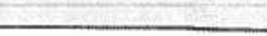

l._9 w/Cornoosite of 23
19 w/Cornoosite of 23
23

480
530

TSI Assessment - before Jan. 11, 2021
Scores are Math Readin
Combined Writin
Combined Writing, Essav, & ABE Option
TSI Assessment 2 - Jan. 11, 2021 and after
Math

English. Language Arts. and Readin
STAAR EXempttons
English Ill - For Both Reading and Writin Al
Course (Waiver

Writin

350
351
Writing 340 & Essav 4
Writin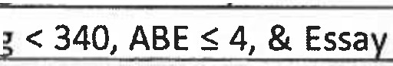 5

950
Score <950 and DLM = 6
945 & 5
ELAR <945, DLL > S. Essav 5

4000
4000

70
70

Math 70

Evidence Based Readin Math
TAAR (Waiver
460
510


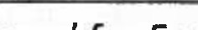
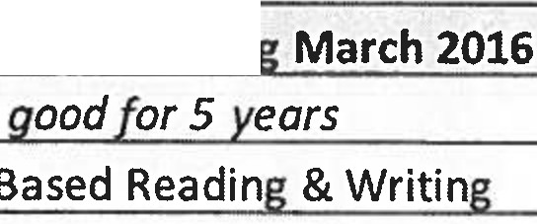


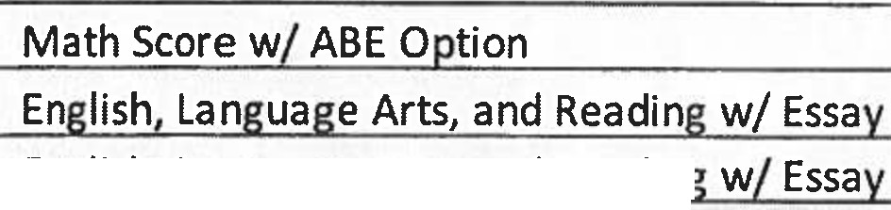

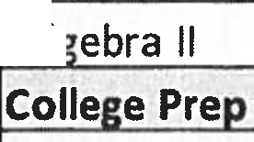
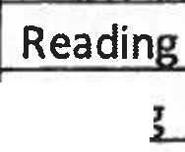
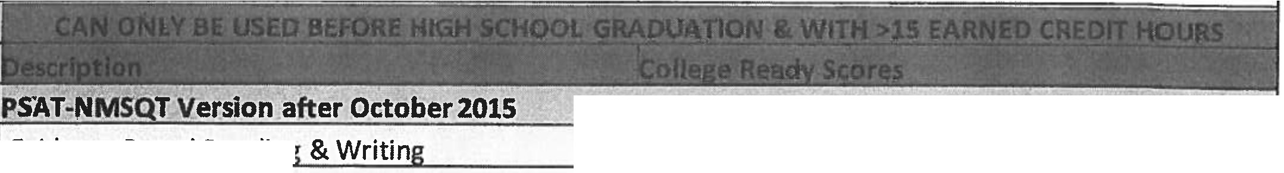
English II - For Both Reading and Writin
HS Algebra II End of Year grade +Algebra I EOC

4000
70 on Ale:ebra II and 4000 on EOC

AppendixB

Roles & Responsibilities of Victoria College's College Access Staff

Dual Credit Specialists assigned to East and West High School, collaborate with VISD counselors, teachers, and staff to assist high school students meet secondary graduation requirements and become college ready. The dual credit specialists are responsible for implementing, coordinating, and evaluating initiatives aimed at enhancing performance on required college readiness and/or other college placement exams. Outreach includes, but are not limited to:

- Class visits
- Parent/student information sessions
- Dual credit presentations
- Application drives
- Scholarship drives
- Utilizing the Remind, College Knowledge, text message app to market events
- Informing students of transferability of dual credit courses
- Guiding students through the admissions process
- Enrolling students in dual credit courses

Appendix C

JUMP START
to College

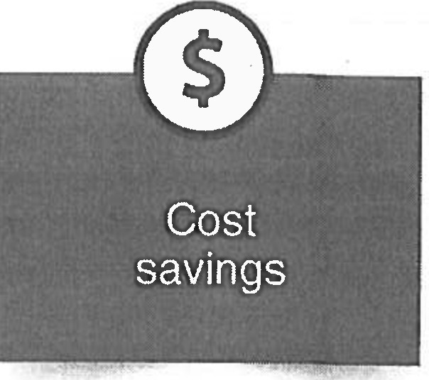
Dual Credit Opportunities With Victoria College

.. ,
'
likely to graduate
3 times more
in 4 years

American History
Electives
Life & Physlcal Sciences

HIST 1301 | HIST 2301 | ACCT 2301 | case 1436 | MATH 2415 | BIOL 1322 | CHEM 1406 | GEOL 1402
HIST 1302 |  | ACCT 2302 | CAIJ 1301 | PSYC 2314 | BIOL 1406 | CHEM 1411 | GEOL 1403
 |  | BIOL 2401 | CRIJ 1306 | SPAN 1411 | BIOL 1407 | CHEM 1412 | GEOL 1404
Communication ENGL 1301 ENGL 2311
BIOL 2402 | ENGR 1201 | SPAN 1412 | BIOL 1408 | ENVR 1301 | PHYS 1310
BUSI 1301 | ENGA 1304 |  | BIOL 1409 | GEOL 1303 | PHYS 1401
BUSI 1307 | MATH 2414 |  | BIOL 2404  BIOL 2420 | GEOL 1305  GEOL 1401 | PHYS 1402

ENGL 1302

Component Area Options
GovernmenUPolitical Science
Mathematics

BCIS 1305 SPCH 1311
case 1301 sPcH 1315
EDUC 1300 SPCH 1318
MATH 1325
GOVT2305
GOVT 2306
MATH 1314 MATH 1342
MATH 1316 MATH 2412
MATH 1324 MATH 2413
MATH 1332

Creative Arts ARTS 1301 DRAM 1310
ARTS 1303 MUSI 1306
ARTS 1304 MUSI 1310
Language, Philosophy, & Culture ENGL 2322 HUMA 1301
ENGL 2323 PHIL 1301 ENGL2327
ENGL2328

Workforce Training
Social & Behavioral Sciences
ECON 2301 PSYC 2301
GEOG 1303 SOCI 1301

BMGT 1307 | CETT 1349 | INTC 1343 | PTAC 1410 | WLDG 1421
BMGT 1327 | EMSP 1160 | INTC 1355 | PTAC 1432 | WLOG2406
CETT 1302 | EMSP 1501 | INTC 2336 | PTAC 2420 | WLDG 2443
CETT 1325 | HPRS 2300 | PTAC 1302 | PTAC 2438
CETT 1341 | INTC 1301 | PTAC 1308 | PTAC 2446

View the High School Dual EnrollmentTulUon & Fees In the Vlcto,ta Col/ego Catalog
G)(361) 582-2400 e EnrollmentServices@VictoriaCollege edu

VICTORIA COLLEGE
An Equa/-Opporwniry l11s1iru/lon

